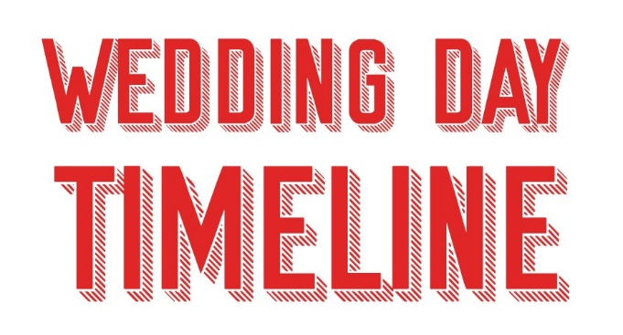

Wake Up 7:30 am
Breakfast: 8:00 am
Bridesmaids Makeup 8:30 am
Bridesmaids Hair 9:00 am
Flowers Delivered 9:30 am
Bridal Makeup 10:00 am
Bridal Hair 10:30 am
Photographer Arrives 9:45 am
Videographer Arrives 10:00 am
Dressing: 10:45 am
Depart for Ceremony 11:15 am
Ceremony Start Time 12:00 pm
(As on the invitation)
Ceremony Start 12:15 pm
(Actual)
Cocktail Hour 12:45 pm
Wedding Breakfast 2:00pm
Band Arrives 2:45 pm
Speeches 3:00pm
Band Starts 4:00 pm
Bridal Party Photos 5:00 pm
Sunset Photos 6:30 pm
Evening Reception 7:00 pm
First Dance 8:00 pm
Reception Ends 12:00 am

Wake Up 7:00 am
Breakfast: 7:30 am
Arrive at Barbers 8:00 am
Photographer Arrives 9:00 am
Videographer Arrives 9:00 am
Dressing: 9:15 am
Have a drink & Relax 10:00 am
Depart for Ceremony 10:45 am
Ceremony Start Time 12:00 pm
(As on the invitation)
Ceremony Start 12:15 pm
(Actual)
Cocktail Hour 12:45 pm
Wedding Breakfast 2:00pm
Band Arrives 2:45 pm
Speeches 3:00pm
Band Starts 4:00 pm
Bridal Party Photos 5:00 pm
Sunset Photos 6:30 pm
Evening Reception 7:00 pm
First Dance 8:00 pm
Reception Ends 12:00 am

Jessica Tait
(Maid of Honour)
444-444-2667

Jenny Ball
(Bridesmaid)
444-444-4556

Ricky Endsleigh
Best Man
444-444-3839

Jessica Rose - Makeup
(MUA)
444-444-3298

Abi - Mae Floral Design
(Florist)
444-444-5678

Vicki - Photography
(Photographer)
444-444-6745

Robin - Loved Up Films
(Videographer)
444-444-6534

Charlotte – Mounton Brook Lodge
(Venue)
444-444-8696

The Colts
(Band)
444-444-7689

